<VIVU>

Software Development Plan (Small Project)

Version <2.0>

Revision History

| **Date** | **Version** | **Description** | **Author** |
| --- | --- | --- | --- |
| 24/10/2023 | 1.1 | Fill out the content of Risk Management | Trần Trung Hiếu |
| 25/10/2023 | 1.2 | Fill out the content of 2 (Project Overview) and 3 (Project Organization) | Hoàng Lê Cát Thanh |
| 25/10/2023 | 1.3 | Fill out the content of Reporting, Configuration Management | Trần Trung Hiếu |
| 25/10/2023 | 1.4 | Fill out the content of 1. Introduction | Đoàn Thị Yến Nhi |
| 26/10/2023 | 1.5 | Fill out the content of 4.2.1 Phase Plan | Lê Ngọc Thảo |
| 26/10/2023 | 1.6 | Update Gantt Chart | Võ Cao Trí |
| 27/10/2023 | 1.7 | Review overall | All members |
| 28/10/2023 | 1.8 | Double-check | All member |
| 03/11/2023 | 1.9 | Update Phase and Iteration Plan | Trí, Thanh, Thảo |
| 11/11/2023 | 2.0 | Complete Revised Project Plan | Trí, Thanh, Thảo |

Table of Contents

**1. Introduction 4**

1.1 Purpose 4

1.2 Scope 4

1.3 Overview 4

2. Project Overview 5

2.1 Project Purpose, Scope, and Objectives 5

2.2 Assumptions and Constraints 5

2.3 Project Deliverables 5

3. Project Organization 6

3.1 Organizational Structure 6

3.2 Roles and Responsibilities 6

4. Management Process 7

4.1 Project Estimates 7

4.2 Project Plan 7

4.2.1 Phase and Iteration Plan 7

4.2.2 Releases 7

4.2.3 Project Schedule 8

4.2.4 Reporting 11

4.2.5 Risk Management 11

4.2.6 Configuration Management 12

Software Development Plan (Small Project)

# Introduction

The introduction of the Software Development Plan (SDP) provides an overview of the entire SDP with purpose, scope, definitions, acronyms, abbreviations, references and overview of the SDP. The introduction to a software development project plan is a critical part of the document because it sets the context and expectations for the project. It helps stakeholders, team members, and decision-makers get a clear understanding of the project's purpose, scope, and objectives, and serves as a foundation for the more detailed planning and execution phases that follow.

## Purpose

The purpose of the *Software Development Plan* is to gather all information necessary to control the project. It describes the approach to the development of the software and is the top-level plan generated and used by managers to direct the development effort.

The following people use the *Software Development Plan*:

* The **project manager** uses it to plan the project schedule and resource needs and to track progress against the schedule.
* **Project team members** use it to understand what they need to do, when they need to do it, and what other activities they are dependent upon.

The purpose of the Software Development Plan (SDP) is multifaceted, serving as a crucial document in the software development process. The primary purposes of an SDP are:

* The project manager uses it to plan the project schedule and resource needs, and to track progress against the schedule.
* Project team members use it to understand what they need to do, when they need to do it, and what other activities they are dependent upon.
* Project clarity: Provide a clear and concise overview of the project, its objectives, and its scope, ensuring that all stakeholders have a common understanding of what the project aims to achieve.
* Scope definition: It clearly defines the scope of the project, including what features and functionalities will be included in the software and what will be excluded. This helps manage expectations and avoid scope creep.
* Team Roles and Responsibilities: Clearly define the roles and responsibilities of team members, ensuring that everyone knows their duties and expectations.

In summary, the purpose of the Software Development Plan is to gather all information necessary to control the project. It describes the approach to the development of the software and is the top-level plan generated and used by managers to direct the development effort.

## Scope

This Software Development Plan describes the overall plan to be used by the VIVU project, including deployment of the product. The scope of a software development project plan defines the boundaries and objectives of the project, outlining what will be accomplished, what won't be included, and how it will be achieved. The plans outlined in this document are based upon the product requirements as defined in the Vision Document.

## Overview

This *Software Development Plan* contains the following information:

Project Overview — describes the project's purpose, scope, and objectives.  It also defines the deliverables that the project is expected to deliver.

Project Organization — describes the organizational structure of the project team.

This Software Development Plan contains the following information:

Project overview - serves as a concise and high-level introduction to a project, providing a quick understanding of its purpose, scope, and key elements.

Project organization - refers to how a project team is structured and how roles and responsibilities are defined within a project.

Management processes - refer to the systematic methods, techniques, and activities employed by organizations to plan, organize, lead, and control their resources and activities to achieve specific goals and objectives.

# Project Overview

## Project Purpose, Scope, and Objectives

* Project Purpose: The project aims to provide a platform for people who want to look for renters for their cars and those who need to rent cars on short notice.
* Scope: The VIVU project will create an app for car owners and renters with all the necessary information and algorithms to provide renters with suitable cars for their needs and car owners with customers who wish to rent their cars. This includes data regarding cars’ information.
* Objectives: The project’s objective is to create an application that helps with the increasing need to rent cars temporarily and make cars on rent easier.

## Assumptions and Constraints

* Assumptions:
  + All team members already have all required skills.
  + The interface will be attractive and user-friendly.
  + The project team has a clear understanding of the scope and requirements.
  + The project team will have sufficient time to complete all project activities and deliverables as planned.
  + The project deliverables will meet client requirements.
  + The project team members will collaborate and communicate effectively throughout the project.
* Constraints:
  + The final result must be delivered before the deadline.
  + All team members must finish their work before the deadline.
  + Team members must keep track of their time to keep up with the plan.
  + Team members must take responsibility for their work.
  + Team members must participate in weekly meetings and report what they have done and their difficulties.

## Project Deliverables

* Weekly Reports - at the end of each week.
* Vision document - 29/10/2023
* Software Development Plan - 29/10/2023
* Sprint Reviews - at the end of each sprint.
* Use-case documents - Sprint 3
* Software architecture document - Sprint 4
* Completed application.
* Test plan.

# Project Organization

## Organizational Structure



## Roles and Responsibilities

| **Person** | **Role** |
| --- | --- |
| Lê Ngọc Thảo - Project Manager, UI/ UX Designer, Frontend Developer, Backend Developer, Tester. | * Responsible for keeping track of the project plan, planning, and scheduling activities. * Responsible for designing the user interface of the app. * Responsible for maintaining the front-end and back-end of the application. * Testing the system and logging the outcomes of that testing. |
| Đoàn Thị Yến Nhi - Business Analyst, Tester. | * Responsible for bridging the gap between IT and the business using data analytics to assess processes, determine requirements, and deliver data-driven recommendations and reports to executives and stakeholders. * Responsible for the interactive elements that work together to form an aesthetically pleasing experience on the interface. * Writing test cases. |
| Hoàng Lê Cát Thanh - UI/ UX Designer, Frontend Developer, Tester. | * Responsible for the interface of the app. * Responsible for the interactive elements that work together to form an aesthetically pleasing experience on the interface. * Testing the system and logging the outcomes of that testing. |
| Võ Cao Trí - Backend Developer, Tester. | * Responsible for designing, building, and maintaining the server side of the applications. * Testing the system and logging the outcomes of that testing. |
| Trần Trung Hiếu - Backend Developer, Tester. | * Responsible for designing, building, and maintaining the server side of the applications. * Writing test cases. |

# Management Process

## Project Estimates

## Project Plan

Every project will have 3 phases (Inception, Elaboration, and Construction) and 4 Iteration/Sprints.

### *Phase and It*eration *Plan*

The detailed tasks will be updated in real-time according to each sprint and feedback from the supervisor.

| Phase | Start date | End date | Overall Objective |
| --- | --- | --- | --- |
| Inception | 9/10/2023 | 27/10/2023 | * Project scope, cost estimation, and risk plan for VIVU app. * Project purpose, functionality * Ensure alignment with stakeholders’ needs and vision |
| Elaboration | 28/10/2023 | 12/11/2023 | * Monitor and control project progress * Use - case specification * App UI, software architecture and class diagram |
| Construction | 12/11/2023 | 24/12/2023 | * Implement features and functionality * Testing |

| Sprint | Start date | End date | Objective |
| --- | --- | --- | --- |
| Sprint 1 | 7/10/23 | 11/10/23 | Setup phase |
| Sprint 2 | 13/10/23 | 29/10/23 | Planning phase |
| Sprint 3 | 30/10/23 | 13/11/23 | Design phase |
| Sprint 4 | 13/11/23 | 27/11/23 | Implement phase |
| Sprint 5 | 27/11/23 | 11/12/23 | Testing phase |
| Sprint 6 | 11/12/23 | 25/12/23 | Testing phase |

### Releases

| Release | Date | Description |
| --- | --- | --- |
| UI prototype | 27/11/23 | visual representation of a user interface that serves as a design mockup to demonstrate the layout, functionality, and visual elements of a software application or website before development begins |
| Demo | 18/12/23 | The demo release is visually appealing and demonstrates the app's key features, but it may not be complete or fully functional. |

### Project Schedule

4.2.3.1 Sprint 1

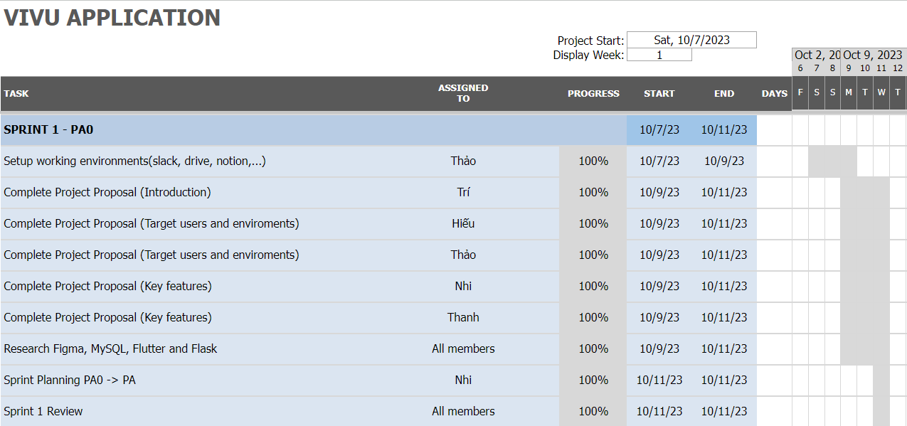

4.2.3.2 Sprint 2

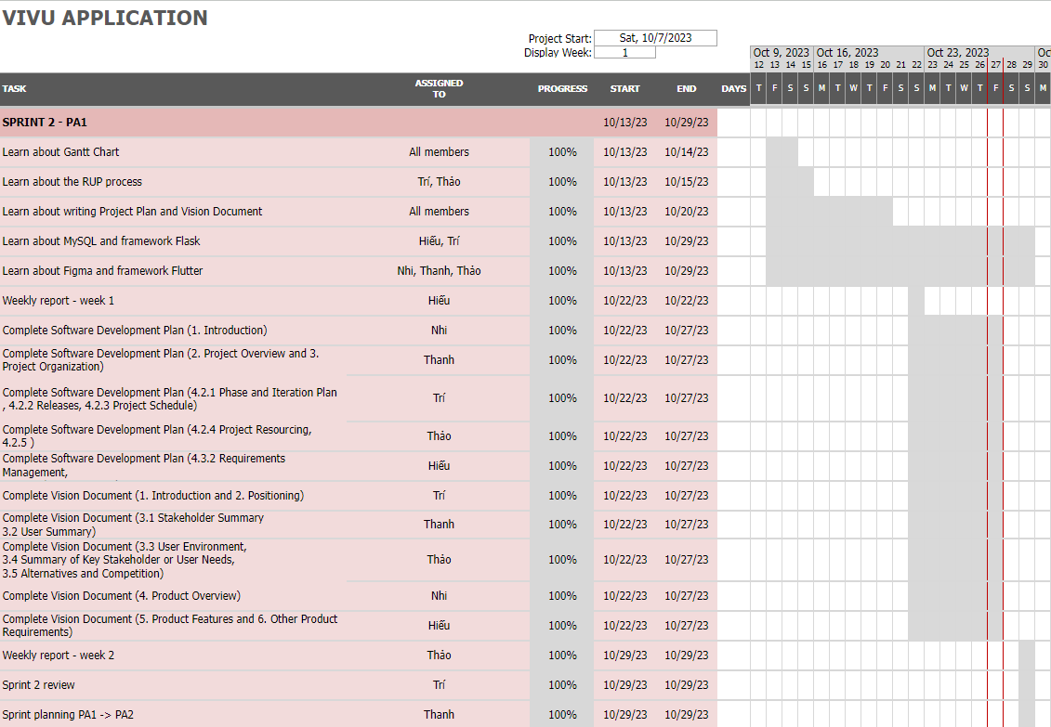

4.2.3.3 Sprint 3

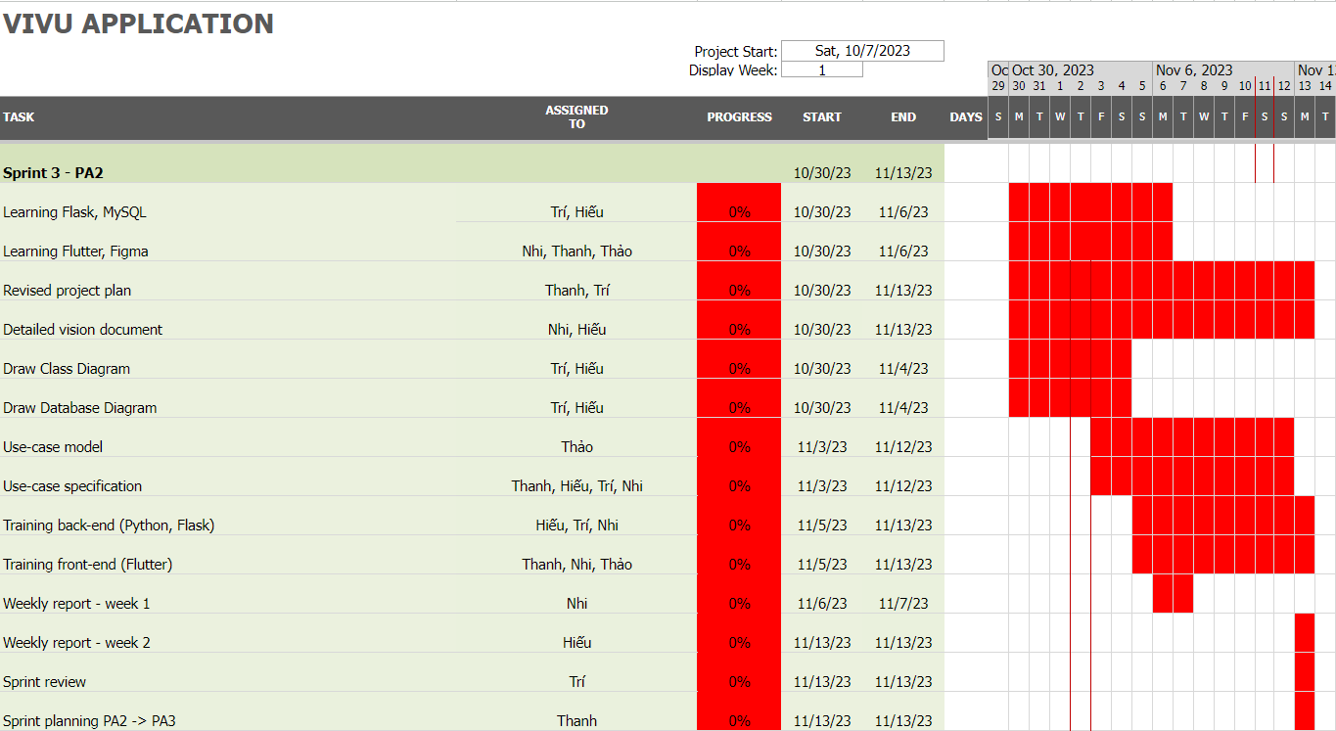

4.2.3.4 Sprint 4

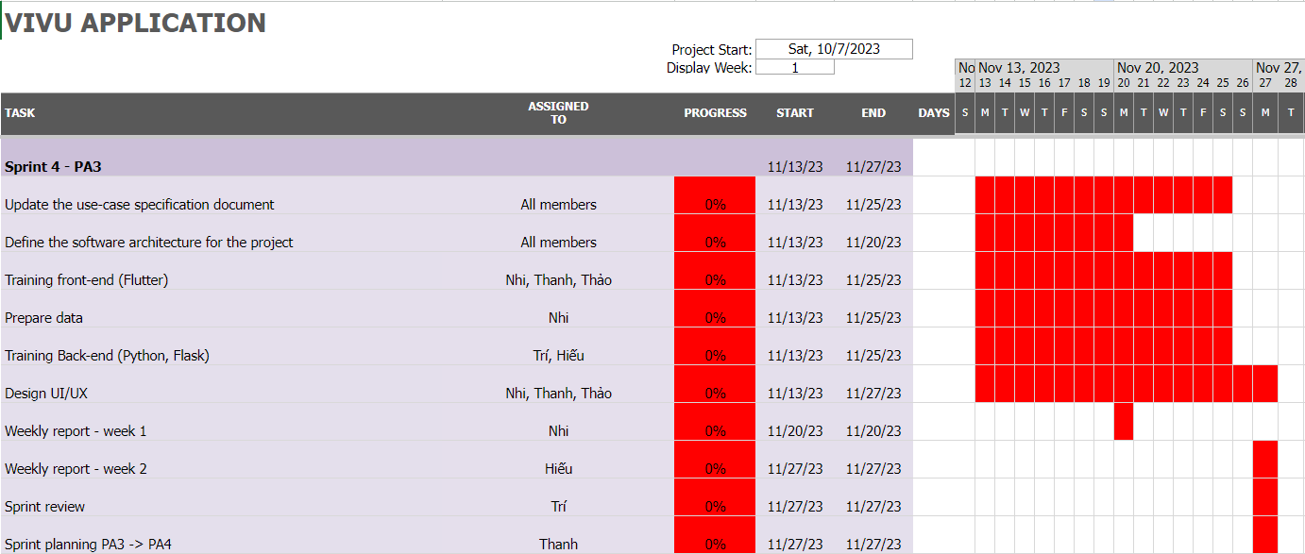

4.2.3.5 Sprint 5

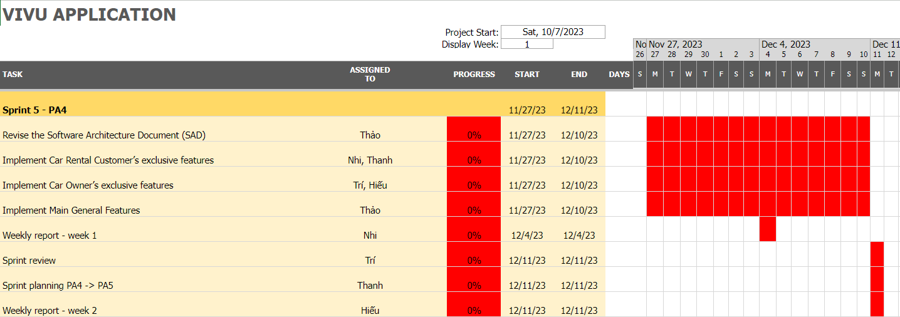

4.2.3.6 Sprint 6

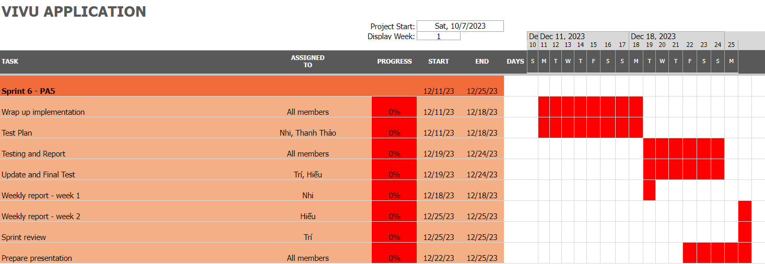

### Reporting

Approaches to report project status:

* Weekly meeting: [Link](https://www.notion.so/264b5b0cfef74187b7fd690726d7f7b0?v=1e6164e5e9804e4593026c2cd60657da&pvs=4)
* Weekly status report: [Link](https://drive.google.com/drive/folders/1LwxwXasU6wt7mINlHeDCS2qfsfwMX632?usp=drive_link)
* Informal chats: [Slack](https://join.slack.com/share/enQtNjA5NjAwMTMzNzIwNy1jMDAzNjA1NWQxZGZiZmYwNDU2YWNkYjRmYjVhYTMzZTE5ZmZkYzAzZmFjOTc1MTBiODU3YzI2ZjU3MDZkZWNj)

### *Risk Management*

Risks will be identified in the Inception Phase using the steps identified in the RUP for Small Projects activity “Identify and Assess Risks”. Project risk is evaluated at least once per iteration and documented in this table. The risks of the greatest magnitude are listed first in the table.

| Risk ID | Risk Description | Probability | Impact | Priority | Mitigation Strategy or Contingency Plan |
| --- | --- | --- | --- | --- | --- |
| 1 | Technical risks: Apps may encounter technical issues, such as system errors, interface errors, or poor security. | Low | High | High | Improve technical quality: Applications need to be regularly tested and maintained to ensure technical quality. |
| 2 | Vague user requirements: Not clearly understanding user requirements leads to the possibility of creating products that do not meet customer expectations | Medium | High | High | Business management should have face-to-face meetings with customers to discuss the products that users want, clarify the functions that users want in the product, and after asking, Business management needs to confirm once again. again |
| 3 | Storage risk: data may be lost due to too large stored information or data being attacked by hackers | Medium | High | High | Build a good enough database system, use security technologies and security solutions to minimize risks and maintain and check the system regularly 2 - 3 weeks per month |
| 4 | Changing customer requirements: customers want a driver instead of driving directly | High | High | High | Add actors to connect with drivers to create jobs and income for more people |
| 5 | Work progress: There are team members who cannot keep up with work progress. A team member has a health or mental problem that leads to not keeping up with the work progress and it can lead to delays in the team's timeline | Medium | Medium | Medium | Pay attention to the member and see if any help is needed and have another member of the team support the work of that member. |
| 6 | Member Knowledge: There are members in the team whose knowledge is slightly lower than other members or the general level needed to do the project. | Medium | Medium | Medium | Carry out self-study on the necessary knowledge for the project or have a training plan for all team members |
| 7 | A project manager with health problems cannot monitor time effectively during a period, leading to a delay in progress. | Medium | Medium | Medium | The team should have 1 person to support the project manager and use project timeline management tools so that all members can collectively manage project time. |
| 8 | Technology changes: the environment used to design projects changes, and the tools used have been replaced by newer tools. | Medium | Low | Low | Learn new technology and organize training and reviews for each other on new technology |
| 9 | Debug: there are errors in the program during execution and debugging delays affect the project progress | High | Low | Low | Let's discuss and learn about those errors online so we can fix them promptly and quickly |

### *Configuration Management*

Tools to be used for storage and sharing source code and files:

* Google Drive: [Link](https://drive.google.com/drive/folders/12JQ6WaPRrds5-OftSW9PJv_vUWEOuDj6?usp=drive_link)
* Github: [Link](https://github.com/HieuTran91/Introduction_To_Software_Engineering-Group-12.git)